James Young Homework 9

**1. First define the omnibus (p.482) factorial hypothesis : state the model, then state each hypothesis test.**

$$μ_{ij}=μ+α_{\dot{i}}+y_{j}+(α{y)}_{ij}$$

The three hypothesis are:

$H_{0}:α_{i}=0$ ${ H}_{1}: α_{i}≠0$

$H_{0}:y_{j}=0$ $H_{1}:y_{j}≠0$

$H_{0}:{(αy)}_{ij}=0$ $H_{1}:{(αy)}_{ij}≠0$

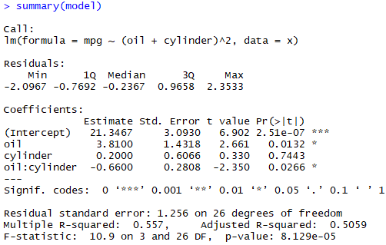**2. Then fit a linear model with oil, cylinder, and interaction of oil*cylinder and use the F value in the summary to test the omnibus hypothesis for all cell means including the interaction. Use the F value and degrees of freedom to perform the test, provide the decision rule, and conclusion.**

The calculated F value for the linear model 10.9 for 3 and 26 df.

Critical F value = 2.99. 10.9>2.99, therefore we can reject $H_{0}$, and conclude that $α_{i},$ $y_{j}$, ${(αy)}_{ij}$ $≠$ 0.

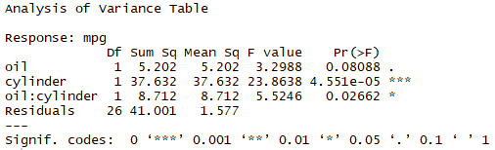**3. Next provide a snip of the anova results and comment on the significance of each group**

Cylinder and oil:cylinder interaction

are significant with p-value <0.05

while oil is not significant with

p-value > 0.05.

**4. Verify ONLY L1 and L3 contrast by hand by calculating the value that proves it is orthogonal, show this using an equation.**

$$∑a_{i}b_{j}=0$$

Where a = L1, i= all L1 data points, b = L2, and j = all L2 data points.

$$∑a_{i}b_{j}=\left(-1⋅0\right)+\left(-1⋅1\right)+\left(-1⋅-1\right)+\left(1⋅0\right)+\left(1⋅1\right)+\left(1⋅-1\right)=0$$

Since the sum of cross products = 0, the contrast is orthogonal.

**5. Interpret the meaning of L4 and L5 in simple language by moving the negative terms to one side and determine what groups are being compared in the contrasts. Explain if this is a good comparison and why. See the picture on D2l on how we split this up.**

The purpose of contrasting L4 is to see if standard oil is different from the other oils at either the 4-cylinder engine or 6-cylinder engine or both. Contrast L5 is comparing the average of gasmiser oil in 4-cylinder engine and multi oil in 6-cylinder engine versus the average of gasmiser oil in the 6-cylinder engine and the multi oil in the 4-cylinder engine.

$$L4:μ11+.5μ22+.5μ23 =μ21+.5μ12+.5μ13$$

$$L5:μ12+μ23 =μ13+μ22$$

**6. Use the pictures we took in class in the review session in D2L to perform basic test statistics for contrasts.**

$H_{0}: L_{2}=0$ $H_{1}: L_{5}≠0$

$$t= \frac{-2.24-0}{\sqrt{1.084*\frac{3}{5}}}=-2.777$$

At α=0.05, the calculated t value = -2.777. Critical t value = -2.0639 (since two-sided t-test). -2.777 < -2.0639, therefore reject the null hypothesis and conclude L2 0.

At α=0.05, the calculated t value = 4.252. Critical t value = 2.0639. 4.252 > 2.0639, therefore we reject the null hypothesis and conclude L5 0.

**8. Use this and fit a multiple regression with all 5 variables and provide the snip like this of the output of the factors**



**9. Verify this model by examining and comparing this with your F value from step 2 and on page 487 in table 9.6.**

The Model F-value on page 487 is 12.27.

**10. Are they the same?**

Yes. My F-statistic from the R-snip (number 8, above) is also 12.27.

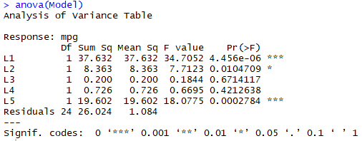**11. Run the anova of the model and provide a snip of the results, which contrasts are significant**?

L1, L2, and L5 are significant contrasts with

calculated F values greater than the

critical F value and p-values < 0.05.

**12. Perform a hypothesis test using the F value from the results of L2 and L5 for separately. State the hypothesis for each, conduct the test, state the decision rule and conclusion. Use Back of book for test.**

α = 0.025 (two-sided t-test), critical F value = 5.72

L2 -> H0: L2 -> H1:

For L2 the calculated F value is 7.7. 7.7 > 5.72, therefore we reject H0 and conclude that for L2.

L5 -> H0: L5 -> H1:

For L5 the calculated F value is 18.1. 18.1 > 5.72, therefore we reject H0 and conclude that $μ≠0$ for L5.

**13. Finally provide a summary of how each of the tests for contrasts, i.e. the omnibus test, the t test, and the F test we performed on certain contrasts are related and what did you find out about the interactions in the contrasts L2 and L5? explain.**

The first tests, the omnibus test and t-test, were the least helpful, but did show significance of factors and interactions. Using F tests for the contrasts we uncovered more actionable information. In L5 we found that 4-cylinder engines had a higher mean mpg than 6-cylinder engines. In L2 we found that specialty oils were better than the standard oil for mean mpg.

R-code appendix

